**Exercise 3: Color Deficiency**

Visualizations hold great importance in presenting and understanding information. Often, they can be the deciding factors in decision making processes. Thus not only it is crucial that relevant information is included and presented, but also it must be effective in delivering a message in a manner that everyone can understand. Since color is a key component of any visual (in fact, it is the second most important channel in effectively expressing categorical attributes), it is necessary to remember that deficiencies in perceiving color affect a large population and must be accounted for. In the idiom presented, color plays a major role in determining which sports each competing country in the Winter Olympics from 1924 to 2006 dominated, by measure of total medal count (at default, but the user can filter the visualization based on Olympics country and year, country competitor, medal type, as well as sport of interest).

Of the various forms of colorblindness, the following types were tested for both weak and blind: Red-Blind/Protanopia, Green-Blind/Deuteranopia, and Blue-Blind/Tritanopia. Blue cone Monochromacy and Achromatopsia were tested as well. All were tested using color-blindness.com using color schemes provided by Colorbrewer2.org.

Red-Weak/Blind

Red hues appeared subdued under Red-Weak colorblindness and lost color entirely in Red-Blind. Notably, curling and ice hockey turned entirely green and gray, respectively, under full Red-Blind color blindness.

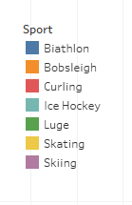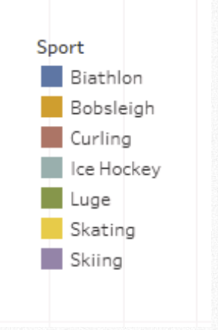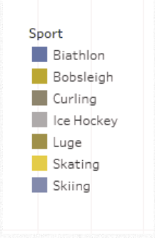

Green-Weak/Blind

When affected by Green-Weak/Blind color blindness, colors drift toward more blues and browns. Notably, both red and green turn brown while purple turns a blue-gray color.

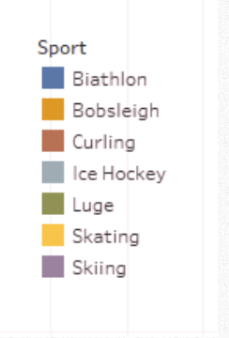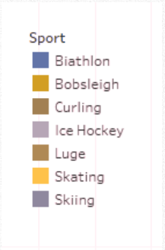

Blue-Weak/Blind

Colors took on a pinkish or greenish hue. Biathlon turned a teal color while skateboarding underwent a transition from yellow to pink entirely.

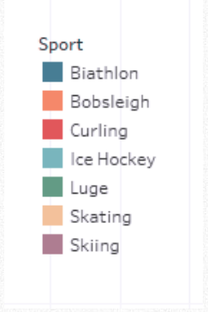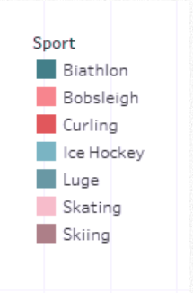

Blue Cone Monochromacy/Achromatopsia

Each color lost vibrance under Blue Cone Monochromacy and lost color entirely using the Achromatopsia filter.

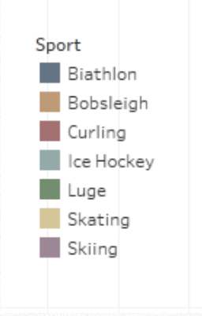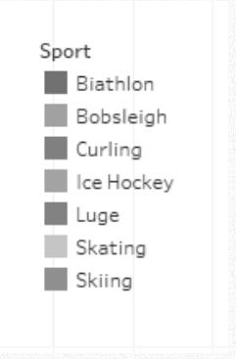

Conclusion:

The original design was created without color blindness in mind and thus an automatic color scheme in Tableau was used. Conveniently, the default color scheme was already adjusted fairly well for color blindness. The palette held up well in protanopia, deuteranopia, as well as tritanopia with each different color still visibly distinguishable from the others. However, under full color blindness, it was revealed that the red, green, and purple hues were very similar and thus adjustments needed to be made.

In order to create a palette suitable for color blindness, a color scheme from Colorbrewer2.org was selected. The site provided predefined color palettes designed for color blindness with an option to select for the amount of categories and which kind (qualitative, sequential, diverging). Our visualization separates medals earned by olympic sport, a qualitative palate was deemed most appropriate. With some additional tweaking on top of the given palette to satisfy the monochromic, a new color scheme was decided on as shown below. In order from left to right: no filter, Protanopia, Deuteranopia, Tritanopia, Blue Cone Monochromacy, and Achromatopsia.

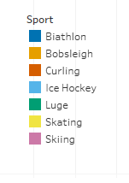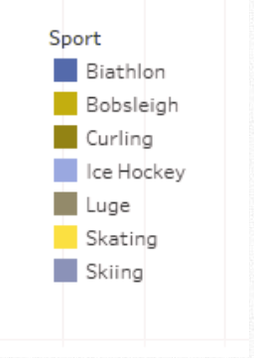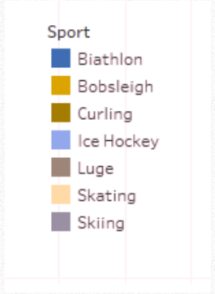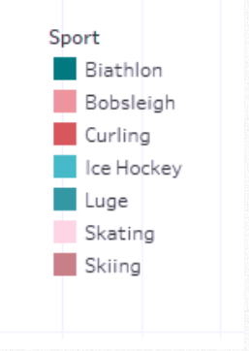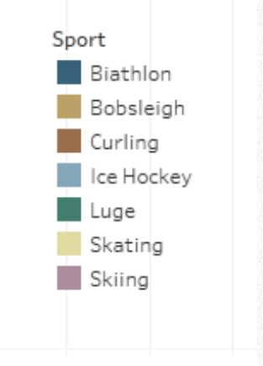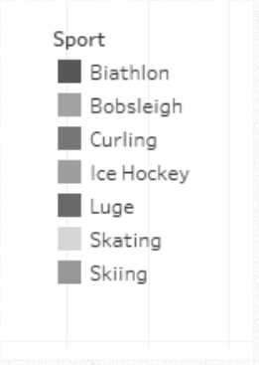

The differences between colors in each test more distinct than before.

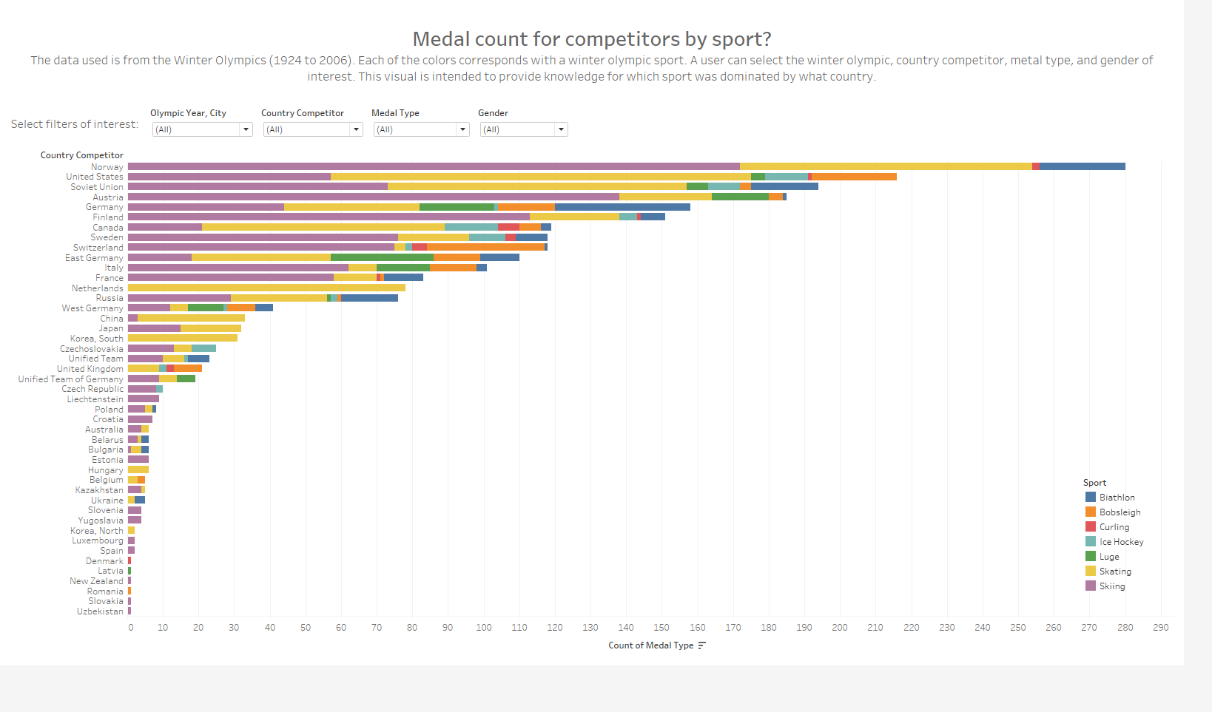

*Figure 1 - Original*

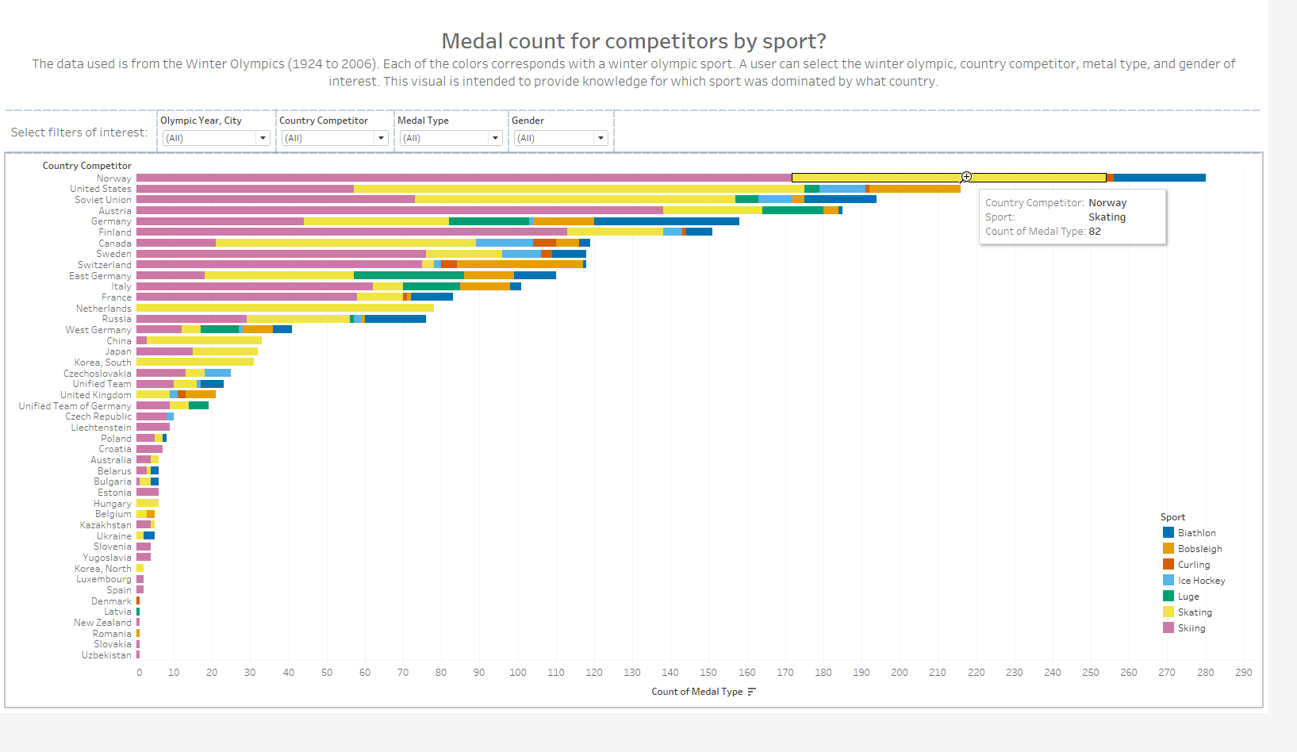

*Figure 2 - Final Color Scheme. Colors are now more vibrant and distinguishable.*